**Deadheads Generator**

***Preference Overview***

The Deadheads Generator preference is an internal device to calculate and complete deadheads missing from the Deadhead Catalog.



The deadheads calculation algorithm for the Generator can be supplied

by the customer

Deadhead, pull out or pull in icons in a Gantt having a white dot in the cen-

ter, for example like this, are auto-generated by the system based on this preference

Here is an example of a Vehicle Gantt with generated deadheads:

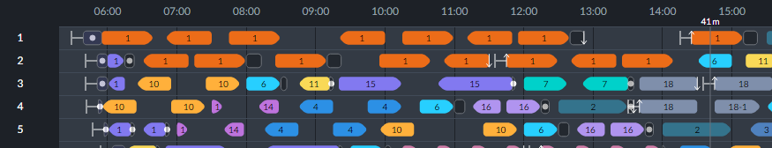

For the moment, there is no baseline preference and there are currently no templates. It may be implemented in Expert Mode by Optibus Professional Services.